Page no. 1
Program 1. : Program to Create the equivalent of a four-function calculator. The Program requires the user to enter two numbers and an operator. It then carries out the specified arithmetical operation: addition, subtraction, multiplication or division of the two numbers. Finally, it displays the result.
Soln:
#include <iostream>
using namespace std;
int main() {
char choice;
do {
double num1, num2, result;
char operators;
cout << "Enter first number: ";
cin >> num1;
cout << "Enter an operator (+, -, *, /): ";
cin >> operators;
cout << "Enter second number: ";
cin >> num2;
if (operators == '+') {
result = num1 + num2;
cout << "Result: " << result << endl;
} else if (operators == '-') {
result = num1 - num2;
cout << "Result: " << result << endl;
} else if (operators == '*') {
result = num1 * num2;
cout << "Result: " << result << endl;
} else if (operators == '/') {
if (num2 != 0) {
result = num1 / num2;
cout << "Result: " << result << endl;
} else {
Page no. 2

cout << "Division by zero is not allowed." << endl;
}
} else {
cout << "Invalid operator!" << endl;
}
cout << "Do you want to perform another calculation? (y/n): ";
cin >> choice;
} while (choice == 'y' || choice == 'Y');
return 0;
}

Output:
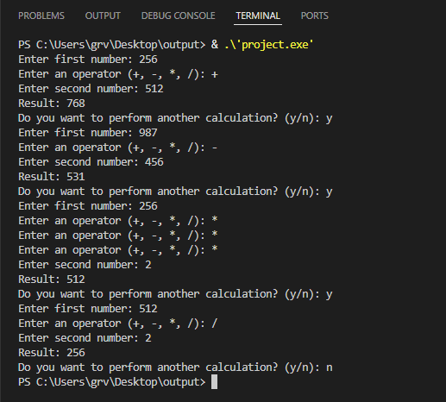

Page no. 3
Program 2. : Program to input a character and to print whether a given character is an alphabet, digit or any other character.
Soln:
#include <iostream>
using namespace std;
int main() {
char inputChar, userChoice;
do {
cout << "Enter a character: ";
cin >> inputChar;
if ((inputChar >= 'A' && inputChar <= 'Z') || (inputChar >= 'a' && inputChar <= 'z')) {
cout << "The character '" << inputChar << "' is an alphabet." << endl;
} else if (inputChar >= '0' && inputChar <= '9') {
cout << "The character '" << inputChar << "' is a digit." << endl;
} else {
cout << "The character '" << inputChar << "' is a special character." << endl;
}
cout << "Do you want to check another character? (y/n): ";
cin >> userChoice;
} while (userChoice == 'y' || userChoice == 'Y');
return 0;
}
Output:
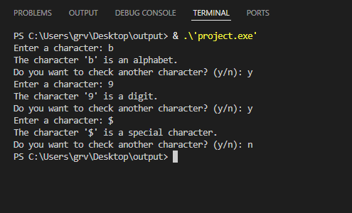

Page no. 4
Program 3. : Program to calculate and print roots of a quadratic equation ax^2+bx+c = 0 (a≠0).
Soln:
#include <iostream>
#include <cmath>
using namespace std;
int main() {
char userChoice;
do {
double a, b, c;
double discriminant, root1, root2;
cout << "Enter a: ";
cin >> a;
while (a == 0) {
cout << "a cannot be zero. Enter again: ";
cin >> a;
}
cout << "Enter b: ";
cin >> b;
cout << "Enter c: ";
cin >> c;
discriminant = b*b - 4*a*c;
if (discriminant > 0) {
root1 = (-b + sqrt(discriminant)) / (2*a);
root2 = (-b - sqrt(discriminant)) / (2*a);
cout << "Roots are real and distinct" << endl;
cout << root1 << " " << root2 << endl;
} else if (discriminant == 0) {
root1 = -b / (2*a);
cout << "Roots are real and equal: " << root1 << endl;
} else {
double real = -b / (2*a);
Page no. 5

double imag = sqrt(-discriminant) / (2*a);
cout << "Roots are complex" << endl;
cout << real << " + " << imag << "i" << endl;
cout << real << " - " << imag << "i" << endl;
}
cout << "Do you want to continue? (y/n): ";
cin >> userChoice;
} while (userChoice == 'y' || userChoice == 'Y');
return 0;
}

Output:
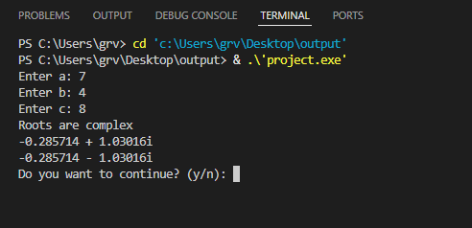

Page no. 6
Program 4. : Program to calculate area of a circle, a rectangle or a triangle depending upon user’s choice.
Soln:
#include <iostream>
#include <cmath>
using namespace std;
int main(){
int choice;
char repeat;
do{
cout << "\nChoose the shape to calculate the area:" << endl;
cout << "1. Circle" << endl;
cout << "2. Rectangle" << endl;
cout << "3. Triangle" << endl;
cout << "Enter your choice (1-3): ";
cin >> choice;
switch (choice){
case 1:
{
double radius, area;
cout << "Enter the radius of the circle: ";
cin >> radius;
if (radius < 0) {
cout << "Radius cannot be negative!" << endl;
}else{
area = M_PI * radius * radius;
cout << "The area of the circle is: " << area << endl;
}
break;
}
case 2:
Page no. 7

{
double length, width, area;
cout << “Enter the length of the rectangle: “;
cin >> length;
cout << “Enter the width of the rectangle: “;
cin >> width;
if (length < 0 || width < 0){
cout << “Length and width cannot be negative!” << endl;
}else{
area = length * width;
cout << “The area of the rectangle is: “ << area << endl;
}
break;
}
case 3:
{
double base, height, area;
cout << “Enter the base of the triangle: “;
cin >> base;
cout << “Enter the height of the triangle: “;
cin >> height;
if (base < 0 || height < 0) {
cout << “Base and height cannot be negative!” << endl;
}else{
area = 0.5 * base * height;
cout << “The area of the triangle is: “ << area << endl;
}
break;
}
default:
Page no. 8

cout << "Invalid choice! Please choose a valid option (1-3)." << endl;
}
cout << "\nDo you want to calculate the area of another shape? (y/n): ";
cin >> repeat;
} while (repeat == 'y' || repeat == 'Y');
cout << "Program exited. Thank you!" << endl;
return 0;
}

Output:
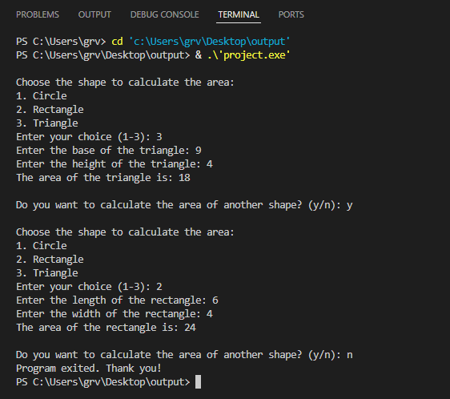

Page no. 9
Program 5. : Program to calculate the factorial of a positive integer.
Soln:
#include <iostream>
using namespace std;
int main(){
int n;
char ch;
do{
cout << "Enter a positive integer to calculate its factorial: ";
cin >> n;
unsigned long long fact = 1;
for (int i = 1; i <= n; i++){
fact *= i;
}
cout << "Factorial = " << fact << endl;
cout << "Repeat? (y/n): ";
cin >> ch;
} while (ch == 'y' || ch == 'Y');
return 0;
}

Output :
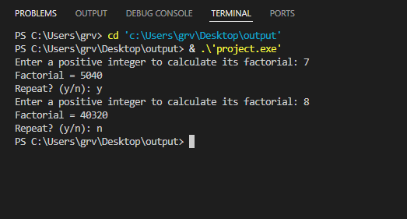

Page no. 10
Program 6. : Program to search for a specific integer in a 1-D array (Linear Search).
Soln:
#include <iostream>
using namespace std;
int main(){
int size, target, found = 0;
char userChoice;
do{
cout << "Enter the size of the array (positive integer): ";
cin >> size;
while (size <= 0){
cout << "Array size must be a positive integer. Please enter again: ";
cin >> size;
}
int array[size];
cout << "Enter " << size << " integers for the array: " << endl;
for (int i = 0; i < size; i++){
cout << "Element " << i + 1 << ": ";
cin >> array[i];
}
cout << "Enter the integer to search in the array: ";
cin >> target;
found = 0;
for (int i = 0; i < size; i++){
if (array[i] == target){
cout << "The integer " << target << " is found at position " << i + 1 << " (index " << i << ")." << endl;
found = 1;
break;
}
}
if (!found)
{
Page no. 11
cout << "The integer " << target << " is not present in the array." << endl;
}
cout << "Do you want to search in another array? (y/n): ";
cin >> userChoice;
} while (userChoice == 'y' || userChoice == 'Y');
cout << "Program exited. Thank you!" << endl;
return 0;
}

Output:
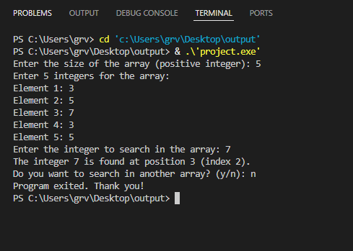

Page no. 12
Program 7. : Program to count the number of employees earning more than Rs 1 lakh per annum. The monthly salaries of 20 employees shall be provided by user.
Soln:
#include <iostream>
using namespace std;
int main(){
const int numEmployees = 20;
double monthlySalaries[numEmployees];
int count = 0;
cout << "Enter the monthly salaries of " << numEmployees << " employees (in ₹):" << endl;
for (int i = 0; i < numEmployees; i++){
cout << "Employee " << i + 1 << ": ";
cin >> monthlySalaries[i];
while (monthlySalaries[i] < 0){
cout << "Monthly salary cannot be negative. Please re-enter: ";
cin >> monthlySalaries[i];
}
}
for (int i = 0; i < numEmployees; i++){
double annualSalary = monthlySalaries[i] * 12;
if (annualSalary > 100000){
count++;
}
}
cout << "\nThe number of employees earning more than ₹1 lakh per annumis: " << count << endl;
return 0;
}

Pgae no. 13
Output:
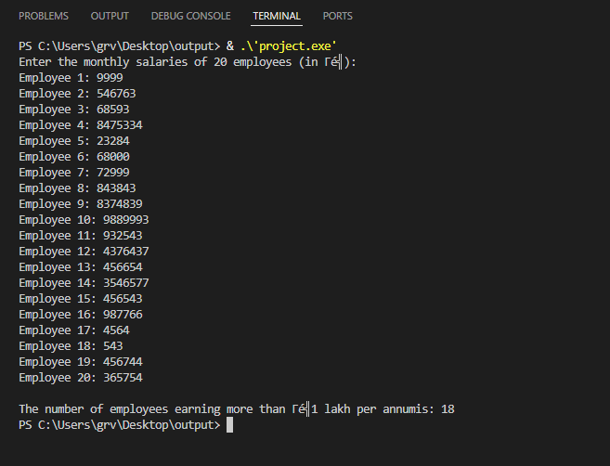

Page no. 14
Program 8. : Program to add two matrices.
Soln:
#include <iostream>
using namespace std;
int main(){
int rows, cols;
cout << "Enter the number of rows for the matrices: ";
cin >> rows;
cout << "Enter the number of columns for the matrices: ";
cin >> cols;
int matrixA[rows][cols], matrixB[rows][cols], result[rows][cols];
cout << "\nEnter elements of the first matrix (Matrix A):" << endl;
for (int i = 0; i < rows; i++){
for (int j = 0; j < cols; j++){
cout << "Element [" << i + 1 << "][" << j + 1 << "]: ";
cin >> matrixA[i][j];
}
}
cout << "\nEnter elements of the second matrix (Matrix B):" << endl;
for (int i = 0; i < rows; i++){
for (int j = 0; j < cols; j++){
cout << "Element [" << i + 1 << "][" << j + 1 << "]: ";
cin >> matrixB[i][j];
}
}
for (int i = 0; i < rows; i++){
for (int j = 0; j < cols; j++){
result[i][j] = matrixA[i][j] + matrixB[i][j];
}
}
cout << "\nThe resulting matrix after addition is:" << endl;
for (int i = 0; i < rows; i++){
Page no. 15
for (int j = 0; j < cols; j++)
{
cout << result[i][j] << " ";
}
cout << endl;
}
return 0;
}

Output:
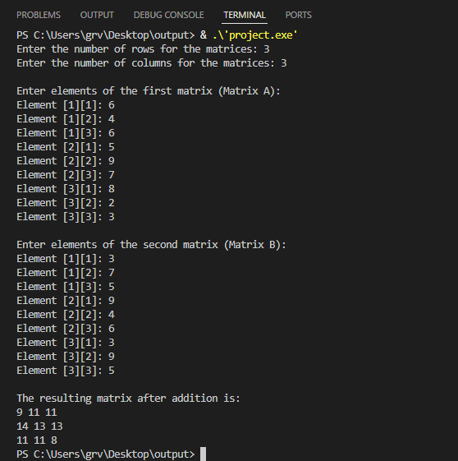

Pgae no. 16
Program 9. : Program to read Sales of 5 salesman in 12 months and to print total sales madebyeachsalesman.
Soln:
#include <iostream>
using namespace std;
int main(){
const int salesmen = 5;
const int months = 12;
double sales[salesmen][months];
double totalSales[salesmen] = {0};
cout << "Enter the sales data for " << salesmen << " salesmen for " << months << " months:\n";
for (int i = 0; i < salesmen; i++){
cout << "\nSalesman " << i + 1 << ":" << endl;
for (int j = 0; j < months; j++){
cout << "Month " << j + 1 << ": rs";
cin >> sales[i][j];
while (sales[i][j] < 0)
{
cout << "Sales cannot be negative. Please re-enter for Month " << j + 1 << ": ₹";
cin >> sales[i][j];
}
totalSales[i] += sales[i][j];
}
}
cout << "\nTotal sales made by each salesman:\n";
for (int i = 0; i < salesmen; i++){
cout << "Salesman " << i + 1 << ": rs" << totalSales[i] << endl;
}
return 0;
}
Page no. 17
Output:
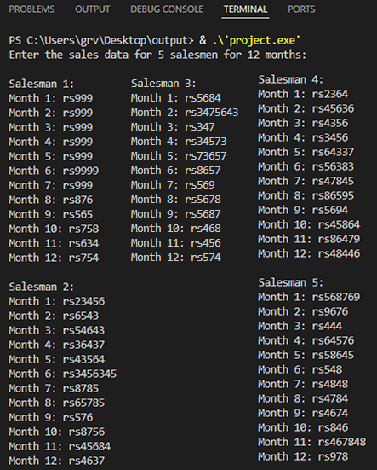
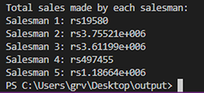

Page no. 18
Program 10. : Program to calculate grades of 4 students from 3 test scores.
Soln:
#include <iostream>
using namespace std;
int main(){
int num_students = 4;
int num_tests = 3;
float scores[num_students][num_tests];
float total, average;
for (int i = 0; i < num_students; i++){
total = 0;
cout << "\nEnter scores for Student " << i + 1 << ":\n";
for (int j = 0; j < num_tests; j++){
cout << "Enter score for Test " << j + 1 << ": ";
cin >> scores[i][j];
total += scores[i][j];
}
average = total / num_tests;
cout << "Student " << i + 1 << " - Total: " << total << ", Average: " << average << ", Grade: ";
if (average >= 90){
cout << "A\n";
}else if (average >= 80){
cout << "B\n";
}else if (average >= 70){
cout << "C\n";
}else if (average >= 60){
cout << "D\n";
}else
{
cout << "F\n";
Page no. 19
}
}
return 0;
}

Output:
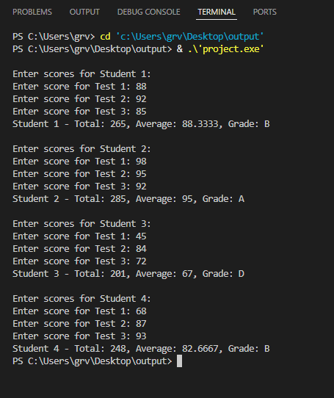

Page no. 20
Program 11. : Write a program that takes a string as input and outputs the reversed string. For example,if the input is "Skillarger", the output should be "regallikS".
Soln:
#include <iostream>
#include <string>
using namespace std;
int main(){
string originalString, reversedString = "";
cout << "Enter a string: ";
cin >> originalString;
int stringLength = originalString.length();
for (int index = stringLength - 1; index >= 0; index--){
reversedString += originalString[index];
}
cout << "Reversed string: " << reversedString << endl;
return 0;
}

Output:
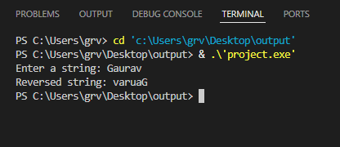

Page no. 21
Program 12. : Write a program to count the number of vowels and consonants in a given string. For example, for the input "Computer", the output should be Vowels: 3, Consonants: 5.
Soln:
#include <iostream>
#include <string>
using namespace std;
int main(){
string inputString;
int vowelsCount = 0, consonantsCount = 0;
cout << "Enter a string: ";
cin >> inputString;
for (int i = 0; i < inputString.length(); i++){
char ch = tolower(inputString[i]);
if (ch == 'a' || ch == 'e' || ch == 'i' || ch == 'o' || ch == 'u'){
vowelsCount++;
}else if ((ch >= 'a' && ch <= 'z'))
{
consonantsCount++;
}
}
cout << "Vowels: " << vowelsCount << ", Consonants: " << consonantsCount << endl;
return 0;
}

Output:
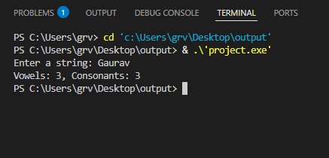
Page no. 22
Program 13. : Write a program to check whether a given string is a palindrome. For example, "level" Is a palindrome, but "hello" is not.
Soln:
#include <iostream>
#include <string>
using namespace std;
int main(){
string inputString;
bool isPalindrome = true;
cout << "Enter a string: ";
cin >> inputString;
int start = 0;
int end = inputString.length() - 1;
while (start < end){
if (tolower(inputString[start]) != tolower(inputString[end])){
isPalindrome = false;
break;
}
start++;
end--;
}
if (isPalindrome){
cout << "The string is a palindrome." << endl;
}else{
cout << "The string is not a palindrome." << endl;
}
return 0;
}

Page no. 23
Output:
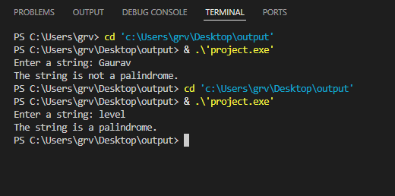

Page no. 24
Program 14. : Write a program that removes duplicate characters from a string. For example, if the input is "programming", the output should be "progamin".
Soln:
#include <iostream>
#include <string>
using namespace std;
int main(){
string inputString, resultString = "";
cout << "Enter a string: ";
cin >> inputString;
for (int i = 0; i < inputString.length(); i++){
bool isDuplicate = false;
for (int j = 0; j < resultString.length(); j++){
if (inputString[i] == resultString[j]){
isDuplicate = true;
break;
}
}
if (!isDuplicate){
resultString += inputString[i];
}
}
cout << "String after removing duplicates: " << resultString << endl;
return 0;
}
Output:
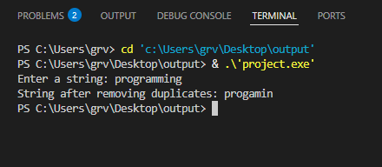
Page no. 25
Program 15. : Write a program to find the longest word in a given sentence. For example, for theinput "C++ is a powerful programming language", the output should be "programming".
Soln:
#include <iostream>
#include <sstream>
#include <string>
using namespace std;
int main(){
string sentence, word, longestWord = "";
int maxLength = 0;
cout << "Enter a sentence: ";
getline(cin, sentence);
stringstream ss(sentence);
while (ss >> word){
if (word.length() > maxLength){
longestWord = word;
maxLength = word.length();
}
}
cout << "The longest word is: " << longestWord << endl;
return 0;
}

Output:
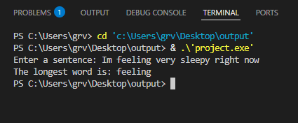

Page no. 26
Program 16. : Program to read values into a nested structure.
Soln:
#include <iostream>
#include <string>
using namespace std;
struct Student{
string name;
int age;
float marks[3];
};
struct Class{
string className;
Student students[3];
};
int main(){
Class classData;
cout << "Enter the class name: ";
getline(cin, classData.className);
for (int i = 0; i < 2; i++){
cout << "\nEnter details for Student " << i + 1 << ":\n";
cout << "Name: ";
getline(cin, classData.students[i].name);
cout << "Age: ";
cin >> classData.students[i].age;
for (int j = 0; j < 3; j++){
cout << "Marks for subject " << j + 1 << ": ";
cin >> classData.students[i].marks[j];
}
cin.ignore();
}
cout << "\nClass Name: " << classData.className << endl;
Page no. 27
for (int i = 0; i < 2; i++){
cout << "\nStudent " << i + 1 << " Details:\n";
cout << "Name: " << classData.students[i].name << endl;
cout << "Age: " << classData.students[i].age << endl;
cout << "Marks: ";
for (int j = 0; j < 3; j++){
cout << classData.students[i].marks[j] << " ";
}
cout << endl;
}
return 0;
}
Output:
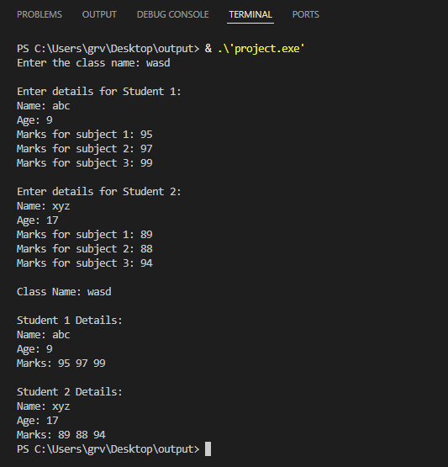
Page no. 28
Program 17. : Program to store information of 10 employees and to display information of an employee depending upon the employee no given.
Soln:
#include <iostream>
#include <string>
using namespace std;
struct Employee{
int employeeNumber;
string employeeName, employeeDepartment;
float employeeSalary;
};
void inputEmployeeDetails(Employee employeeList[], int totalEmployees){
for (int index = 0; index < totalEmployees; index++){
cout << "\nEnter details for Employee " << index + 1 << ":\n";
cout << "Employee Number: ";
cin >> employeeList[index].employeeNumber;
cin.ignore();
cout << "Name: ";
getline(cin, employeeList[index].employeeName);
cout << "Department: ";
getline(cin, employeeList[index].employeeDepartment);
cout << "Salary: ";
cin >> employeeList[index].employeeSalary;
}
}
void displayEmployeeDetails(const Employee &employee){
cout << "\n===== Employee Details =====\n";
cout << "Employee Number : " << employee.employeeNumber << endl;
cout << "Name : " << employee.employeeName << endl;
cout << "Department : " << employee.employeeDepartment << endl;
cout << "Salary : " << employee.employeeSalary << endl;
Page no. 29
cout << "=============================\n";
}
void searchEmployeeByNumber(Employee employeeList[], int totalEmployees, int searchEmployeeNumber){
for (int index = 0; index < totalEmployees; index++){
if (employeeList[index].employeeNumber == searchEmployeeNumber){
displayEmployeeDetails(employeeList[index]);
return;
}
}
cout << "Employee with Employee Number " << searchEmployeeNumber << " not found.\n";
}
int main(){
const int TOTAL_EMPLOYEES = 10;
Employee employeeList[TOTAL_EMPLOYEES];
cout << "===== Employee Information System =====\n";
inputEmployeeDetails(employeeList, TOTAL_EMPLOYEES);
char userChoice;
do{
int searchEmployeeNumber;
cout << "\nEnter Employee Number to search: ";
cin >> searchEmployeeNumber;
searchEmployeeByNumber(employeeList, TOTAL_EMPLOYEES, searchEmployeeNumber);
cout << "\nDo you want to search for another employee? (y/n): ";
cin >> userChoice;
} while (userChoice == 'y' || userChoice == 'Y');
cout << "\nThank you for using the Employee Information System. Goodbye!\n";
return 0;
}

Page no. 30

Output:
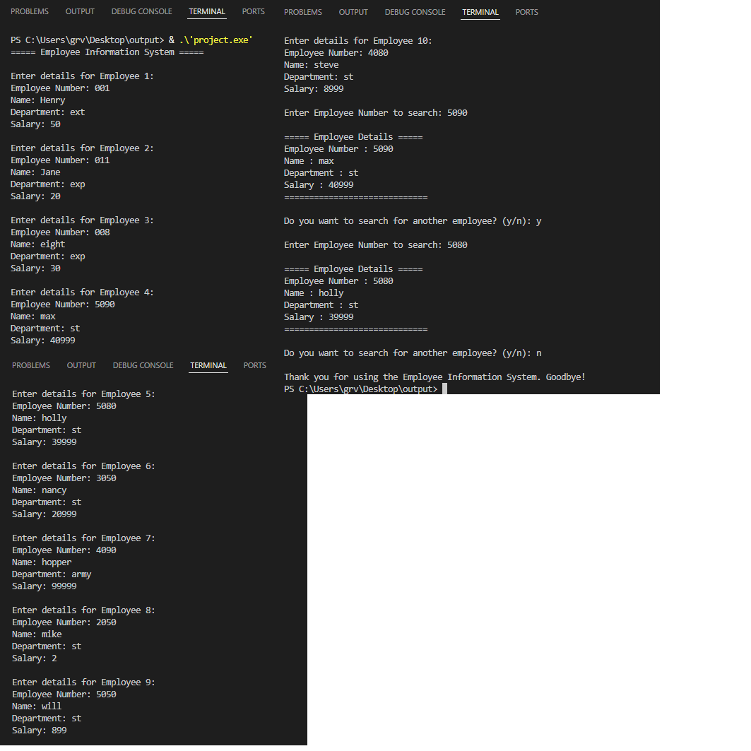

Page no. 31
Program 18. : Program to accept and print a student’s result using a structure having array inside it.
Soln:
#include <iostream>
#include <string>
using namespace std;
struct Student{
string name;
int rollNo;
float marks[5];
float totalMarks;
float percentage;
};
void calculateResult(Student &student){
student.totalMarks = 0;
for (int i = 0; i < 5; i++){
student.totalMarks += student.marks[i];
}
student.percentage = (student.totalMarks / 500) * 100;
}
int main(){
Student student;
cout << "Enter student name: ";
getline(cin, student.name);
cout << "Enter student roll number: ";
cin >> student.rollNo;
cout << "Enter marks for 5 subjects:\n";
for (int i = 0; i < 5; i++)
{
cout << "Subject " << i + 1 << " marks: ";
cin >> student.marks[i];
}
Page no. 32
calculateResult(student);
cout << "\nStudent Result:\n";
cout << "Name: " << student.name << endl;
cout << "Roll No: " << student.rollNo << endl;
cout << "Marks: ";
for (int i = 0; i < 5; i++)
{
cout << student.marks[i] << " ";
}
cout << endl;
cout << "Total Marks: " << student.totalMarks << endl;
cout << "Percentage: " << student.percentage << "%" << endl;
return 0;
}

Output:
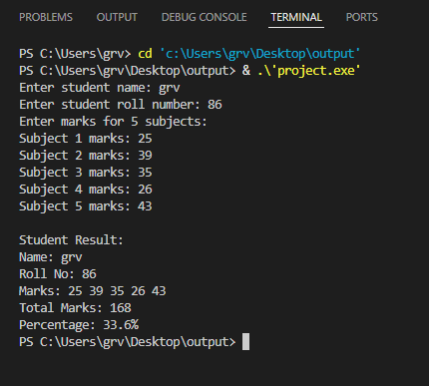

Page no. 33
Program 19. : Program to illustrate passing of structures by value.
Soln:
#include <iostream>
#include <string>
using namespace std;
struct Student{
string name;
int age;
float marks;
};
void displayStudentDetails(Student student){
cout << "\nInside the function (After passing by value):\n";
cout << "Name: " << student.name << endl;
cout << "Age: " << student.age << endl;
cout << "Marks: " << student.marks << endl;
student.marks += 5;
cout << "\nModified Marks Inside Function: " << student.marks << endl;
}
int main(){
Student student1;
cout << "Enter student name: ";
getline(cin, student1.name);
cout << "Enter student age: ";
cin >> student1.age;
cout << "Enter student marks: ";
cin >> student1.marks;
cout << "\nBefore passing to function (By value):\n";
cout << "Name: " << student1.name << endl;
cout << "Age: " << student1.age << endl;
cout << "Marks: " << student1.marks << endl;
displayStudentDetails(student1);
Page no. 34
cout << "\nAfter returning from function (Original structure is unchanged):\n";
cout << "Name: " << student1.name << endl;
cout << "Age: " << student1.age << endl;
cout << "Marks: " << student1.marks << endl;
return 0;
}

Output:
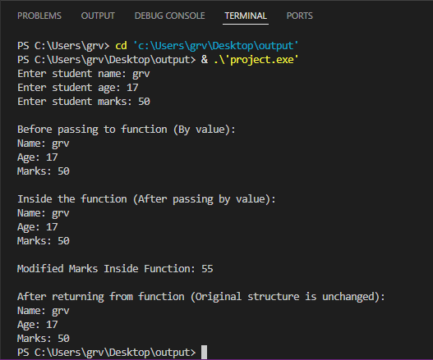

Page no. 35
Program 20. : Program to illustrate passing of a structure by reference.
Soln:
#include <iostream>
#include <string>
using namespace std;
struct Student{
string name;
int age;
float marks;
};
void modifyStudentDetails(Student &student){
cout << "\nInside the function (After passing by reference):\n";
cout << "Name: " << student.name << endl;
cout << "Age: " << student.age << endl;
cout << "Marks: " << student.marks << endl;
student.marks += 10;
cout << "\nModified Marks Inside Function: " << student.marks << endl;
}
int main(){
Student student1;
cout << "Enter student name: ";
getline(cin, student1.name);
cout << "Enter student age: ";
cin >> student1.age;
cout << "Enter student marks: ";
cin >> student1.marks;
cout << "\nBefore passing to function (By reference):\n";
cout << "Name: " << student1.name << endl;
cout << "Age: " << student1.age << endl;
cout << "Marks: " << student1.marks << endl;
modifyStudentDetails(student1);
Page no 36
cout << "\nAfter returning from function (Original structure is modified):\n";
cout << "Name: " << student1.name << endl;
cout << "Age: " << student1.age << endl;
cout << "Marks: " << student1.marks << endl;
return 0;
}

Output:
